**R CODE of ASSIGNMENT-2**

(GENERATING RANDOM WALK PROCESS WITH X[t] WHERE)

#i)X[t]~N(0,S^2)

**CODE:**

S<-1

X=rnorm(1000,mean=0,sd=S)

y=NULL

y[1]=0

for(i in 2:1000)

{

y[i]=y[i-1]+X[i]

}

random_walk=ts(y)

plot(random_walk,main ='i)Random walk',ylab='',xlab='Days',col='orange')

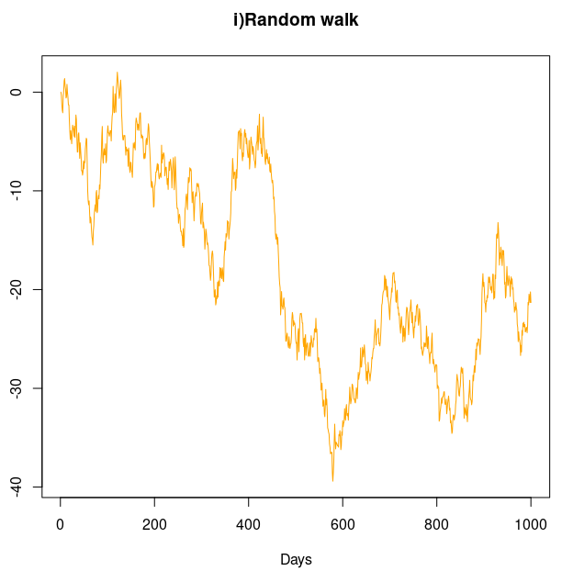**OUTPUT:**

#ii)X[t]~Binom(1,p)

**CODE:**

p<-0.5

Xn=sample(c(-1,1),1000,replace=TRUE,prob = c(p,1-p))

yn=NULL

yn[1]=0

for(i in 2:1000)

{

yn[i]=yn[i-1]+Xn[i]

}

random_walk_n=ts(yn)

plot(random_walk_n,main ='ii)Random walk',ylab='',xlab='Days',col='red')

**OUTPUT:**

